**CHAPTER 6**

**SYSTEM ANALYSIS**

* **Need Of SignSpeak**
* **Process Model**
* **Feasibility Study**
* **Features**

1. **NEED OF SIGNSPEAK**

The need for SignSpeak, a sign language to text conversion project, arises from the following key factors:

1. **Bridging Communication Gaps:** For the millions of deaf or hard-of-hearing individuals who rely on sign language, communicating with those who do not understand sign language can be a significant challenge. SignSpeak helps bridge this gap by converting sign language into written text, enabling easier communication in everyday situations.
2. **Inclusivity and Accessibility:** In many public spaces such as hospitals, banks, or workplaces, there is often a lack of interpreters. SignSpeak promotes inclusivity by providing a technological solution that ensures accessibility for the deaf community, reducing their reliance on human interpreters.
3. **Enhancing Independence:** With SignSpeak, individuals who use sign language can communicate independently in real-time without needing a third party. This increases their autonomy, especially in settings where immediate communication is essential.
4. **Educational Use:** SignSpeak can be a valuable tool in educational environments, helping students who are deaf or hard of hearing to participate more fully in classrooms, lectures, or group discussions. It also allows non-signing educators and students to interact with signing students.
5. **Efficiency in Services:** Public and private service providers can benefit from SignSpeak by improving service delivery for the deaf community. For example, in customer service, legal proceedings, or medical consultations, the tool can facilitate more accurate and immediate communication.
6. **Promoting Understanding of Sign Language:** By increasing the visibility and use of sign language in various environments, SignSpeak can raise awareness and foster greater understanding and appreciation of sign language among the general population.

In summary, SignSpeak is needed to create a more inclusive, accessible, and efficient communication system between sign language users and non-signers, enhancing their day-to-day interactions and improving access to services and opportunities**.**

1. **PROCESS MODEL**

A process model is an essential component of software development that outlines the steps involved in developing a project. For the SignSpeak sign language to text conversion system, the Incremental process model will be used. This approach is ideal for this project because it involves building the system in small, manageable increments, allowing for frequent testing, refinement, and user feedback. This results in a high-quality product that evolves to meet user needs effectively.

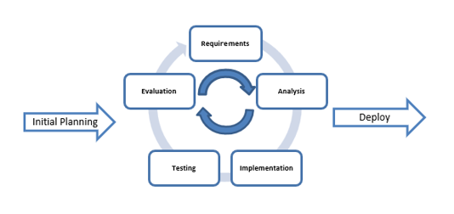

Fig. No. 6.2.1 Incremental Project Management

The Incremental methodology is a way of developing a project step by step. Instead of building the entire system at once, the project is broken down into smaller parts called increments. In the first phase, the team figures out the main requirements and decides which features to work on first. With each new increment, the team builds a portion of the project, tests it, and collects feedback, which helps improve the application over time.

For the SignSpeak project, each increment will focus on adding specific features, like basic sign language recognition, generating text output, and expanding the sign vocabulary. The team will meet regularly during each phase to check progress, solve any problems, and organize tasks. After completing an increment, the team will show the new feature to users and stakeholders to get their feedback. This feedback will be used to make improvements in the next development phase, ensuring that the app becomes better and meets user needs.

Each increment will follow four steps: Planning, where the team sets goals, breaks down tasks, and assigns them; Development, where they build the required features, like improving recognition accuracy or adding more signs; Testing and Feedback, where the increment is tested to make sure it works properly and feedback is gathered from users; and Integration, where the new feature is smoothly added to the existing system. After each increment, the team will have a review meeting to look at what went well, what didn’t, and what can be improved for the next phase.

This process allows the team to continuously improve the project and adapt to changing needs or feedback. The Incremental model works well for the SignSpeak project because it lets the team add new features without disrupting the overall system. It also helps make sure the final product meets the needs of both sign language users and the community.

In conclusion, the Incremental model is a great fit for the SignSpeak project. It allows the project to improve step by step, adapt to user feedback, and respond to changing requirements, which helps deliver a high-quality product that effectively bridges communication gaps.

1. **FEASIBILITY STUDY**

A feasibility study is an important aspect of any project to determine whether it is viable, achievable, and beneficial. This study will assess the technical, operational, economical, and schedule feasibility of developing a sign language to text conversion system called signspeak.

1. **Technical feasibility**

Technical feasibility refers to the assessment of whether the proposed project can be developed using the available technology, skills, and resources. In the case of the SignSpeak sign language to text conversion project, the technical feasibility study will evaluate the technical requirements for building the platform.

Firstly, the technical feasibility study will assess the compatibility of the project with the existing technology infrastructure. This involves ensuring that SignSpeak can be developed using available programming languages, machine learning frameworks, and image processing tools. It will evaluate whether the current hardware (such as cameras for capturing sign language) and software (such as algorithms for gesture recognition and text generation) can support the development of the project. Additionally, the study will consider the scalability of the system to handle a wide range of sign languages and adapt to new signs over time.

Secondly, the feasibility study will evaluate the availability of skilled personnel and expertise required to develop the project. This includes assessing the qualifications and experience of software developers, machine learning experts, natural language processing (NLP) specialists, and UI/UX designers. If there are gaps in expertise—such as the need for specialists in gesture recognition or computer vision—the study will determine whether additional training or outsourcing will be required to fill those gaps.

Thirdly, the technical feasibility study will assess the security and privacy requirements of the project. The study will evaluate whether necessary security measures, including encryption and secure data storage, can be implemented to protect user privacy and comply with data protection regulations.

Lastly, the feasibility study will consider the cost of the technical resources required to develop the project. This includes the cost of acquiring or leasing hardware (e.g., high-resolution cameras), software licenses for machine learning and NLP tools, and the expenses related to hiring or outsourcing skilled technical personnel. It will also assess whether the budget is sufficient to cover ongoing maintenance, updates, and potential scaling of the platform.

In summary, the technical feasibility study for the SignSpeak sign language to text conversion project will assess the compatibility of the project with the existing technology infrastructure, the availability of skilled personnel, security and privacy requirements, and the cost of the technical resources required for successful development. This evaluation will ensure that the project can be completed efficiently, securely, and within budget.

1. **Operational Feasibility**

Operational feasibility refers to the ability of an organization to integrate a proposed system into its daily operations. The operational feasibility of the SignSpeak sign language to text conversion project is determined by evaluating its impact on existing workflows, user adoption, and the organization’s capacity to support the new system.

One key aspect of operational feasibility is the willingness of end-users to adopt and use the system. For SignSpeak to be successful, it must be designed with an intuitive, user-friendly interface that accommodates the needs of both deaf individuals and those who interact with them. The platform should accurately convert sign language into text in real time and should be easily accessible across devices. Ensuring the system meets the expectations of its target users—including individuals who are deaf or hard of hearing, educators, and customer service personnel—will be critical for adoption.

Another aspect of operational feasibility is the availability of resources to support the system. This includes having the necessary hardware, such as cameras capable of capturing sign language gestures, and software, including machine learning models for sign recognition. The organization must ensure there are sufficient resources to develop, implement, and maintain SignSpeak. This may require additional training for existing staff or hiring new personnel with expertise in fields like gesture recognition, natural language processing, and machine learning.

The availability of technical support is also essential for operational feasibility. The organization must ensure that technical support is available to assist users if they encounter difficulties with the system. The support team should be capable of addressing issues related to sign language recognition accuracy, user interface problems, or system malfunctions. It is important that the support be timely and available as needed to maintain user satisfaction and system reliability.

The impact of SignSpeak on existing processes is another critical factor. The organization must assess how the new system will change current workflows, including communication practices, customer service interactions, and education delivery methods. This could involve rethinking roles and responsibilities for staff who regularly interact with sign language users. The organization must also ensure that these changes are clearly communicated and embraced by all stakeholders involved.

Finally, the costs and benefits of implementing SignSpeak must be evaluated. This includes the expenses associated with developing, implementing, and maintaining the system, as well as potential benefits, such as improved communication for deaf individuals, enhanced accessibility, and increased customer or user satisfaction. The organization needs to assess whether the benefits of using the system justify the investment, especially in terms of improving accessibility and reducing communication barriers.

In summary, operational feasibility is a vital part of the feasibility study for the SignSpeak project. It is important to assess the system's impact on existing processes, the availability of resources and technical support, and the costs and benefits of implementation. By thoroughly evaluating these factors, the organization can determine the operational feasibility of SignSpeak and ensure its successful integration and adoption.

1. **Economic Feasibility**

Economic feasibility is a crucial aspect of any project and often determines whether or not to move forward. In the case of SignSpeak, a sign language to text conversion application, economic feasibility refers to the ability of the project to generate sufficient revenue to cover its development, operational costs, and deliver a reasonable return on investment (ROI).

To assess the economic feasibility of SignSpeak, several key factors need to be considered. These include the cost of development, which involves software development, machine learning integration, and user interface design. Additionally, ongoing maintenance costs—such as updates, bug fixes, and server expenses—must be accounted for. Another important consideration is the cost of marketing the app to its target audience, including the deaf community, educational institutions, customer service platforms, and healthcare organizations.

To determine potential profitability, a detailed financial analysis should be conducted, considering all costs and revenue streams. This analysis must also take into account the growth potential of the assistive technology market, which is expected to expand as accessibility becomes a more prominent global issue. Additionally, potential competition from other sign language recognition platforms and any legal or regulatory issues related to data privacy and accessibility must be factored into the financial projections.

Overall, the economic feasibility of SignSpeak will depend on its ability to generate sufficient revenue to cover its costs and deliver a reasonable return on investment. Careful financial planning, market analysis, and strategic partnerships will be critical for success. Continuous monitoring and adaptation to market conditions will also be necessary to ensure long-term sustainability and profitability.

1. **Schedule Feasibility**

Schedule feasibility refers to the likelihood that the project can be completed within the specified time frame. For the SignSpeak sign language to text conversion project, it is essential to determine whether the project timeline is realistic and achievable, and whether any potential challenges could cause delays. A well-structured project schedule should be created, outlining all tasks, their expected completion dates, and any dependencies between tasks.

Schedule feasibility is especially critical for the SignSpeak project, as accessibility tools like this are in high demand, and delays could impact the project’s ability to stay competitive in the rapidly evolving technology landscape. To ensure that the project timeline is feasible, the team must first identify all the tasks required to complete the project, including development, testing, data collection, and user feedback integration. They must then estimate the duration of each task and create a project schedule that defines the timeline for each phase of the project.

One of the challenges in developing an assistive technology app like SignSpeak is the need to incorporate evolving technologies, such as machine learning and gesture recognition. Keeping up with the latest advancements while adhering to the project schedule can be difficult. The team must ensure that they have access to the necessary tools, technologies, and datasets needed to complete the project on time. Additionally, a clear understanding of the resources available and any constraints, such as dependencies on external vendors or data collection processes, is vital to prevent delays.

Another factor that can impact the project timeline is the availability of team members. The team must ensure that they have enough developers, machine learning experts, and other personnel with the required expertise to complete the project within the allocated time frame. If key team members are unavailable or if there is a shortage of specialized skills, it could lead to project delays. As a result, resource allocation must be carefully planned and monitored.

In summary, schedule feasibility is crucial for the success of the SignSpeak project. By creating a detailed project schedule, anticipating potential roadblocks, and using project management software to monitor progress, the team can ensure that the project is completed within the specified timeframe. This will enable SignSpeak to be launched in a timely manner, improving its chances of success in the competitive market for accessibility tools.

1. **FEATURES**

SignSpeak should has several features to provide a seamless user experience. Some of the key features that the app should include are as follows:

1. **User-Friendly GUI:**

* The app features an intuitive and easy-to-navigate graphical user interface (GUI) designed to enhance user experience.
* Responsive design ensures that the interface adapts well to different screen sizes and orientations, providing a seamless experience on various devices.

Fig. No. 6.4.1 Landing page

1. **Dark/Light Theme:**

* The app provides a theme toggle feature, allowing users to switch between dark and light modes based on their preference.
* The Dark Mode offers a low-light interface for better readability in dim environments, reducing eye strain.
* The Light Mode provides a bright interface, making it ideal for well-lit environments.

Fig. No. 6.4.2 Light Theme page

Fig. No. 6.4.3 Dark Theme page

1. **Sign Images for Learning:**

* The app includes a comprehensive collection of JPG images that illustrate various sign language gestures.
* Each image displays a clear representation of a specific sign, enabling users to see the correct hand shape and positioning.
* Users can refer to these images as visual aids to practice and mimic the signs, enhancing their learning process.
* This feature promotes effective learning by providing a visual reference, making it easier for users to grasp and reproduce sign language gestures accurately.

Fig. No. 6.4.4 Number Image page

Fig. No. 6.4.5 Alphabet Image page

1. **Camera Control (Start/Stop):**

* The app allows users to easily control the camera for real-time hand gesture recognition.
* **Start**: Users can initiate the camera feed to begin detecting and recognizing sign language gestures.
* **Stop**: Users can pause or stop the camera when they are done with the recognition process, conserving system resources and providing better control over the session.

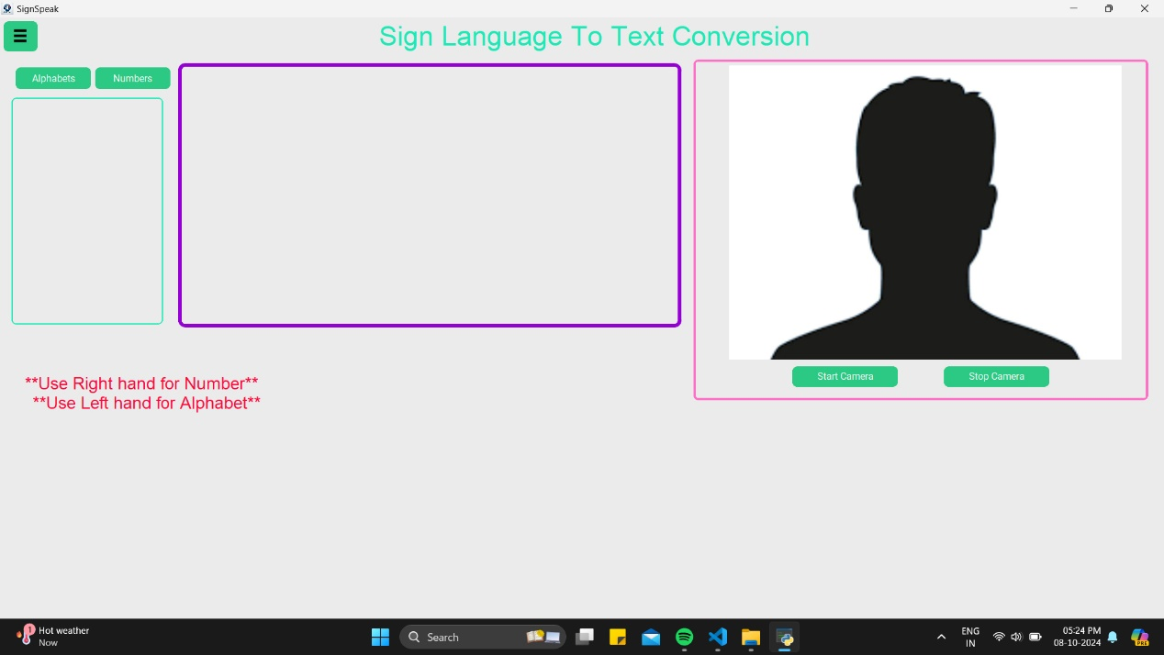

Fig. No. 6.4.6 Camera Control Start Page

Fig. No. 6.4.7 Camera Control Stop Page